Several years ago I pointed out the potential clue HUGEPAW and the fact the the word LION shared Ls with the word LOCATION and attributed it to the Mystery of the Sphinx.

There was more.

Starting with the riddle:

BETWEEN SUBTLE SHADING AND THE ABSENCE OF LIGHT LIES THE NUANCE OF IQLUSION

A subtle shading is a HUE.

The absence of light could refer to NHODR (n\nHodr\nNorse (Scandinavian) god of winter and darkness).

Now look at the clear text solution. Between the HUE and the NHODR lies the nuance of illusion.

LION is the word that LIES (a cute play on words) between HUE and NHODR.

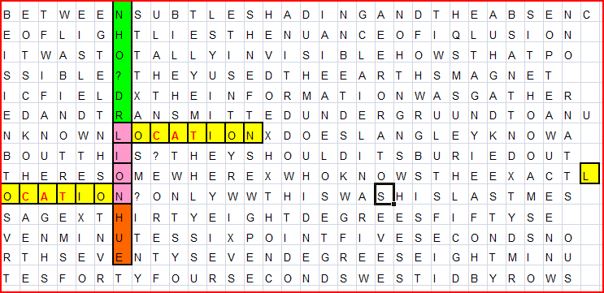
The beginning of the Riddle was a set of directions to point you to the word LION and its two attached words LOCATION in the shape of an S.

This discovery, like any other, would have caused increased scrutiny in this thought to be solved text.

The next sentence: It was totally invisible how is that possible. This could be a mirror or even a reference to a lying LION.

The third sentence: They used the Earth’s magnetic field. This might be a reference to memory storage, but it might hold a secondary reference to Atlantis. Where the careful choice of these words in these sentences and their positions in the matrix becomes interesting is in the following pattern of words: THEY USED THE ART OF ILQUSION ( an E was omitted after the word THE)

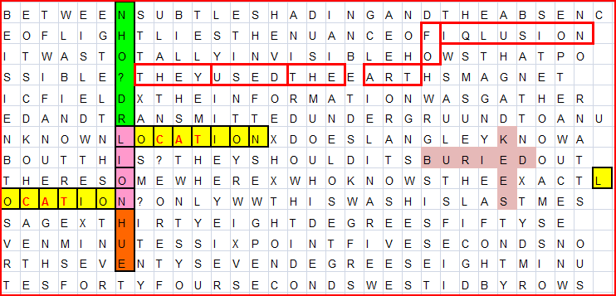

The author of the Art of Illusion was John Mulholland. John resigned as editor of the SPHINX, a famous magician’s magazine, to work for the owners of Kryptos. John Mulholland was not a trivial character and very possibly one of the main characters whom James Sanborn was referring to when he said “Not that it doesn't say something about clandestine trade craft. A lot of the work (I do) deals with secrecy and ... the modus operandi of spies -- how they operate, how they turn sources and things like that. Even the (other) pieces at the agency that are in the courtyard -- stone layers that have encoded text on them -- sort of dealt with secrecy as an entity, which has existed through time for eons and generations. Cave people (for example) keeping secret their methods of killing a mammoth or something like that.”

So if we were to sum up the meaning of this section of Kryptos we might get:

Lion = Sphinx
Location = location of the Sphinx
Author of the Art of Illusion = Sphinx
They used the Earth’s magnetic field = (per Edgar Cayce) the people of Atlantis ( purported builders of the Sphinx) and/or a simple form of information storage
Information was gathered and transmitted underground = Hall of Records (also, per Edgar Cayce built by the people of Atlantis)
Buried Keys = to enter the Hall of Records ( which, is per Edgar Cayce, is under the right paw of the Sphinx)

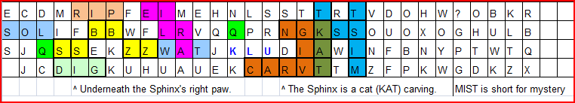

The yellow cells are representative of the Sphinx (not a pyramid).

It lies between the sun (sol) and the water (wat) of the Nile.

Per Edgar Cayce the Hall of Records (not unlike the Library of Alexandra) is under the right paw of the Sphinx.

Eilra means lion.

The Sphinx was carved from bedrock long ago. Its age is disputed due to its advanced weathering of its rock. It is thought to be by some considerably older than the pyramids and written history itself. The Egyptian Pharaoh, who only refurbish it thousands of years ago, might have been wrongly giving credit for building it.

The Sphinx and the mystery around it I believe is meant to point us to the Hall of Records in this puzzle.

The gathering and storage of data and knowledge is the basic theme.

I believe there is a further connection to the idea of wisdom (ie. The Solomon Keys) that knowledge is not enough and at times dangerous, or even deadly.

The idea that the pursuit of knowledge (without wisdom) is often dangerous, or even deadly, but it is something humans have been compelled to do since the beginning of time and brings us to the larger theme which is Biblical.

In Eden there were many fruit bearing trees. We could take our pick of any of them including the Tree of Life. We were welcome to live forever in paradise, providing we did not eat from the tree of knowledge and evil. The compulsion to know was what got us into trouble.

Knowledge without wisdom.

I believe the petrified tree and cryptic data streaming from it in the courtyard represents the Tree of Knowledge in Eden. That courtyard is not a public place and permission is required for you to be there. Tree of Life is at MIT.

And he comes one more stretch of the imagination: The busted up rocks that are scattered about represent the passage of time. One of the flat stones near the bog in the pictures of the courtyard looks like the profile of the Sphinx. Several sets of the layered rocks resemble the strata in the bed rock of the Sphinx’s paws and side after many ions of weathering. I believe the artist James Sanborn wanted to put the Sphinx in ruins to symbolize the future. The picture of the piece of broken rock with a compass (an important logo at that facility) partly covered over by both ground and time represents ions from now when even the facility is in ruins, that the Tree of Knowledge as old as it is still stands.

There are still a lot of other clues and leads I think I have found. If I am right, the puzzle still has much more to be solved than those 97 characters.

It is a shame that so many smart people refuse to attempt this puzzle because it seems overwhelming. I can’t believe how slowly the puzzle’s solution has progressed. It would be great to be even partially right.

If any of this makes sense I’ll explain the X’s and Q’s.

Thanks,
Mike

